

User Requirements Specifications



ICT & Software Engineering - Semester 2

Class: S2-CB-01

Group: 4

Tutor: Chung Kuah

Location: Fontys ICT, R10 building, Eindhoven

Group „BulCari“ members:

Stoycho Stoychev – 4292723

Tony Jiang – 4172507

Stela Trencheva – 4095200   
 Veronika Valeva – 4090349

Date: February/March 2021

Table of Contents

Agreements with client 3

Actors and responsibility 3

Data constraints 3

Functional Requirements 4

Use cases 5

**Use case-01:** Log in. 5

**Use case-02:** Change password. 5

**Use case-03:** Add Employee. 6

**Use case-04:** Remove Employee. 6

**Use case-05:** View Employee Information. 6

**Use case-06:** Change Employee Contract. 7

**Use case-7:** Add products 7

**Use case-8:** Remove product 8

**Use case-9:** Stock Requests Processing 8

**Use case-10**: View Product data 8

**Use case-11:** View Stock Statistics 9

**Use case-12:** Product Search. 9

**Use case-13:** View Employee Statistics 9

**Use case-14:** View Overall Statistics 10

**Use case-15:** Employee search. 10

**Use case-16:** Add department. 10

**Use case-17:** Assign department manager to department. 11

**Use case-18: Calculate the product cost**. 11

**Use case-19:** Log Out. 11

**Use case-20:** Generate Automatic Schedule. 12

**Use case-21:** Edit Shift. 12

**Use case-22:** Assign Employees To Shifts. 13

**Use case-23:** Remove assigned employees from shifts 13

**Use case-24:** Change maximum amount of assignable employees for a particular 14

**Use case-25:** View shifts 14

**Use case-26:** Accept/Deny Holiday Requests. 15

**Use case-27:** View Registered Holidays 15

**Use case-28:** Delete Department 16

**Use case-29:** Modify Department 16

Gui 18

Website wireframe 22

# Agreements with client

## Actors and responsibility

|  |  |
| --- | --- |
| Actors | Responsibility |
| HR Admin | Manage employees: adding employees and removing employees. |
| Department manager | Assign work shift to store employees and assigning store employees to a department.  Assign store worker to department. |
| Stock manager | Managing product and assign work shift to stock employees |
| Stock worker | See restock request. |
| Store manager | Managing department, see employees’ statistic and see product statistic. |
| Cashier | Manage the cashier application. |
| Store worker | Able to send stock request. |

## Data constraints

* Agreed on a meeting in week 6.
* Prefer color for the application is light blue color.
* Media Bazaar opens at 7:30 to 20:30
* Media Bazaar opens for 7 days a week
* The HR admin should be able to add employees, renew employees’ contract and remove employees.
* Keep contract history of employees.
* Contract information: full time contract, 80% contract and flex contract.
* Full time contract: 40 hours a week.
* 80% contract: 32 hours a week.
* Flex contract: on call when store need more workers.
* First time contract is a one-year contract.
* Renew contract 3 times for three years after that contract with no end date.
* Department manager should be able to see statistics about the individual store employee and assign work shift to store employees.
* Stock manager should be able to see statistic about the individual stock employee and assign work shift to stock employees.
* Stock workers should be able to see data about stock and incoming shelf restock requests.

**For all the employees we should store:**

1. First name
2. Last name
3. Address (street, street number, zip code, town, country)
4. Personal e-mail address
5. Username
6. Password
7. Date of birth
8. Date of first working day
9. BSN number
10. Emergency telephone number
11. Bank account number
12. Hourly wage
13. Department(s)
14. Position
15. Level
16. Photo
17. Availability
18. FTE
19. Contract type
20. Contract start date
21. Contract history information

**For the product we should store:**

1. Product Number
2. Brand
3. Type
4. Model
5. Description
6. Category
7. Subcategory
8. Cost Price
9. Sales Price
10. Amount in store (on the shelf)
11. Amount in warehouse

# Functional Requirements

**FR-01: The application should let the user log in and log out.**

**FR-02: The user can change their password.**

**FR-03: HR admin should be able to manage employees.**

**FR-04: Store manager should be able to see statistic about resources.**

**FR-05: Stock manager should be able to manage products.**

**FR-06: Stock worker should be able to see restock request in the application and see product data.**

**FR-07: Store manager should be managed department.**

**FR-08: Department manager should be able to assign store worker to department.**

**FR-9: Cashier should be able to manage the cashier application.**

**FR-10: Department manager and stock manager should be able to assign work shift to employees.**

**FR-11: Stock Manager should be able to accept/deny restock requests.**

# Use cases

### **Use case-01:** Log in.

Related: **FR-01.**

**Actor:** HR admin/ Department manager/ Stock manager/ Stock worker.

**Main Success Scenario:**

1. Actor enters the username and password and confirms.
2. The application let the actor into the profile.

**Extensions:**

1a: Enter wrong username and password.

1. Application displays an invalid credentials message.
2. Returns to MSS step 1.

### **Use case-02:** Change password.

Related: **FR-02.**

**Actor:** HR admin/Store manager/Stock manager/ Department manager/ Stock worker

**Pre-condition:** Must log in.

**Main Success Scenario:**

1. Actor input old password information, new password information, repeat new password and confirms.
2. Application saves the information and display a successful message.

**Extensions:**

1a: input wrong password in the old password field.

1. Application displays a message with wrong password.
2. Returns to MSS step 1.

1b: Actor input the old password in the new password field.

1. Application displays a message with the password is already use.
2. Returns to MSS step 1.

1c: the new password is different than the repeat password field.

1. Application displays a message with repeat password does not match your new password
2. Returns to MSS step 1.

1d: empty field input.

1. Application displays a message with your input is not valid.
2. Returns to MSS step 1.

### **Use case-03:** Add Employee.

Related: **FR-03.**

**Actor:** HR admin.

**Pre-condition: :** must log in as HR admin and go to manage employee profile

**Main Success Scenario:**

1. Actor input employee information and confirms.
2. Application saves the information and display it on a screen.

**Extensions:**

1a: Some requirements information has not been filled in.

1. Application displays a message to fill the missing requirement information.
2. Returns to MSS step 1.

1b: The employee already exists in the application by the same BSN number.

1. Application di displays an error message saying this person already added.
2. Returns to MSS step 1.

### **Use case-04:** Remove Employee.

Related: **FR-03.**

**Actor:** HR admin.

**Pre-condition: :** must log in as HR admin and go to manage employee profile.

**Main Success Scenario:**

1. Actors select an employee and confirms remove.
2. Application removes employee but keeps the record of employee.

### **Use case-05:** View Employee Information.

Related: **FR-03.**

**Actor:** HR admin.

**Pre-condition:** must log in as HR admin and go to manage employee profile.

**Main Success Scenario:**

1. Actors select an employee and confirms.
2. Application displays the selected employee’s full information.

**Extensions:**

1a: Actor didn’t select an employee and confirm.

1. Application displays a message with please select an employee.
2. Returns to MSS step 1.

1b: Actor select an empty space.

1. Application displays a message with please select an employee.
2. Returns to MSS step 1.

### **Use case-06:** Change Employee Contract.

Related: **FR-03.**

**Actor:** HR admin.

**Pre-condition:** must log in as HR admin and go to manage employee profile.

**Main Success Scenario:**

1. Actors select an employee and chooses a new contract type.
2. Application changes the contract type of the employee.

### **Use case-7:** Add products

Related: **FR-06.**

**Actor:** Stock manager.

**Pre-condition:** must log in as stock manager and go to product.

**Main Success Scenario:**

1. Actor input product details and confirms.
2. Application displays a message “success”

**Extension:**

1a: Actor didn’t fill all the information for the product.

1. The application displays an error message.
2. Return to MSS step 1.

1b: Actor fill the information in the wrong field.

1. The application displays an error message.
2. Return to MSS step 1.

### **Use case-8:** Remove product

Related: **FR-06.**

**Actor:** Stock manager.

**Pre-condition:** must log in as stock manager.

**Main Success Scenario:**

1. Actor select a product and confirm.
2. Application deletes product and display the current product.

### **Use case-9:** Stock Requests Processing

Related: **FR-07.**

**Actor:** Stock worker.

**Pre-condition:** must log in as stock worker.

**Main Success Scenario:**

1. System displays incoming restock requests.
2. Actor clicks on a request.
3. System displays info about the requested stock.
4. If the stock is available and the request can be processed, actor clicks “Approve”.
5. System removes request from incoming requests, adds it to “approved requests” tab page and shows appropriate message.

**Extensions:**

5a: There is no availability of the requested stock in the warehouse or request cannot be processed.

1. Actor clicks “Reject”
2. System removes request from incoming requests, adds it to “rejected requests” tab page and shows appropriate message.
3. End of use case

### **Use case-10**: View Product data

Related: **FR-07.**

**Actor:** Stock worker.

**Pre-condition:** must log in as stock worker.

**Main Success Scenario:**

1. The actor clicks to view product data.
2. The application display product data.

### **Use case-11:** View Stock Statistics

Related: **FR-04.**

**Actor:** Store manager.

**Pre-condition:** must log in as stock manager.

**Main Success Scenario:**

1. The actor chooses “Stock statistics”.
2. The application displays statistics about all products (name, quantity, serial number)

### **Use case-12:** Product Search.

Related: **FR-06 – FR07.**

**Actor:** Store manager/ stock worker.

**Pre-condition:** must log in as stock manager.

**Main Success Scenario:**

1. The actor inputs the serial number of the wanted product.
2. The application displays information about the product found.

**Extensions**

1a. actor input an unknown serial number.

1. The application displays an unknown serial number error.
2. Return to MSS step 1.

### **Use case-13:** View Employee Statistics

Related: **FR-04.**

**Actor:** Store manager.

**Pre-condition:** must log in as store manager and go to employee statistic.

**Main Success Scenario:**

1. The actor chooses a date and chooses an employee and confirms it.
2. The application displays employee information (name, last name, hourly wage etc.).

### **Use case-14:** View Overall Statistics

Related: **FR-04.**

**Actor:** Store manager.

**Pre-condition:** must log in as store manager and go to employee statistic.

**Main Success Scenario:**

1. The actor chooses a date and chooses a statistic to be shown and confirms it.
2. The application displays the information of the chosen statistic

### **Use case-15:** Employee search.

Related: **FR-03.**

**Actor:** HR admin.

**Pre-condition:** must log in as HR admin and go to manage employees’ profile.

**Main Success Scenario:**

1. The actor enters the ID number of the wanted employee.
2. The application displays the information about the found employee.

**Extensions**

1a. actor input an unknown ID number.

1. The application displays an unknown ID number error.
2. Return to MSS step 1.

### **Use case-16:** Add department.

Related: **FR-08.**

**Actor:** Store manager.

**Pre-condition:** must log in as store manager and go to department.

**Main Success Scenario:**

1. The actor creates the department and confirms
2. The application adds the department and display a message that it’s successfully added.

**Extensions**

1a. actor input the same code that is already use.

1. The application displays a message that the department already exist.
2. Return to MSS step 1.

### **Use case-17:** Assign department manager to department.

Related: **FR-08.**

**Actor:** Store manager.

**Pre-condition:** must log in as store manager and go to department.

**Main Success Scenario:**

1. The actor picks a department manager and assign it to a department and confirms it.
2. The application displays a message that it is successfully assign.

**Extensions**

1a. actor assign a department manager that is already assign to a department.

1. The application displays a message that the department manager is already assign.
2. Return to MSS step 1.

### **Use case-18: Calculate the product cost**.

Related: **FR-10.**

**Actor:** Cashier.

**Pre-condition:** must log in as cashier.

**Main Success Scenario:**

1. The actor picks a product and amount of product and confirms it.
2. The application displays the total amount that the client needs to play.

### **Use case-19:** Log Out.

Related: **FR-01.**

**Actor:** HR admin/Department manager/ Stock manager/Store manager /Stock worker.

**Pre-condition:** you must be login first**.**

**Main Success scenario:**

1. The actor clicks the button “Log Out”.
2. The application logs out the user and displays the log in page.

### **Use case-20:** Generate Automatic Schedule.

Related: **FR-10.**

**Actor:** Department Manager/ Stock manager / Store manager.

**Pre-condition:** must log in as department, store or stock manager

**Main Success Scenario:**

1. Actor goes to “Schedule”
2. System displays calendar and departments to choose from
3. Actor clicks “Generate Schedule”.
4. System creates a schedule and assign employees from the selected department to shifts checking the business rules:

* To how many shifts has employee been assigned for the day (should be max 3)
* To how many hours an employee has been assigned to for the week and checks whether he/she has reached the max contractual hours
* Does the shift already contains the employee being assigned
* Have the maximum assignable employees in shift been assigned
* Has the employee marked him/herself available for the shift

1. System display created schedule and how many employees have been assigned to each shift, coloring the cells in green(all places in the shift have been filled with employees), orange(some places have been filled), red(no places are filled)
2. Actor clicks “Save Schedule”.
3. System save the schedule in the database and show a confirming message

**Extensions:**

6a: Actor double clicks on shift in the created table

1. System displays the assigned employees names to the selected shift
2. End of use case

6b: Actor clicks “Discard Schedule”

1. Return to MS step 2

### **Use case-21:** Edit Shift.

Related: **FR-10.**

**Actor:** Department Manager/ Stock manager / Store manager.

**Pre-condition:** must log in as department, store or stock manager and reached step 6a.1 in Use-case-20

**Main Success Scenario:**

1. Actor goes to “Edit Schedule”
2. System displays edit mode of the selected schedule (assigned employees to the shift, available employees for the shift from the same department and employees with flex contract from other departments and to how many hours each employee has been assigned for the week, number of the assignable employees for the shift)

### **Use case-22:** Assign Employees To Shifts.

Related: **FR-10.**

**Actor:** Department Manager/ Stock manager / Store manager.

**Pre-condition:** must log in as department, store or stock manager and reached step 10 on Use-case-21

**Main Success Scenario:**

1. Actor needs to select one of the available employees and click “Assign”
2. System adds the employee to assigned employees for this shift and shows confirming message and updates the hours the employee has been assigned with in available employees for the week in which the selected shift is, by adding 4 hours and updates how many employees are left to be assigned for the shift

**Extensions:**

9c: The number of employees left to be assigned for this shift is 0

1. System shows a warning message and don’t assign the employee to the shift
2. End of use case

9d: The employee was assigned for the maximum amount of contractual hours for the week

1. System shows a warning message, assign the employee to the shift and highlight it in red color in other shifts available employees
2. End of use case

### **Use case-23:** Remove assigned employees from shifts

Related: **FR-10.**

**Actor:** Department Manager/ Stock manager / Store manager.

**Pre-condition:** must log in as department, store or stock manager and reached and reached step 10 on Use-case-21

**Main Success Scenario:**

1. Actor needs to select an employee from assigned employees to the particular shift and click “Remove”
2. System removes the employee from assigned employees for this shift, shows confirming message and updates the hours the employee has been assigned with in available employees for the week in which the selected shift is, by subtracting 4 hours and updates how many employees are left to be assigned for the shift

### **Use case-24:** Change maximum amount of assignable employees for a particular

Related: **FR-10.**

**Actor:** Department Manager/ Stock manager / Store manager.

**Pre-condition:** must log in as department, store or stock manager and reached and reached step 10 on Use-case-21

**Main Success Scenario:**

1. The actor enters a value in the maximum employees per shift and clicks “Change”
2. System updated the maximum employees that can be assigned to the selected shift and the number of employees that are left to be assigned to the selected shift

**Extensions:**

1b: The entered value is smaller than the already assigned employees to the shift

1. System displays a warning message and don’t update the value

### **Use case-25:** View shifts

Related: **FR-10.**

**Actor:** Department Manager/ Stock manager / Store manager.

**Pre-condition:** must log in as department, store or stock manager and reached and reached step 2 on Use-case-20

**Main Success Scenario:**

1. Actor clicks “View Schedule”.
2. System display created schedule and how many employees have been assigned to each shift, coloring the cells in green(all places in the shift have been filled with employees), orange(some places have been filled), red(no places are filled)
3. Actor double clicks on shift
4. System displays assigned employees

**Extensions:**

3b. Actor clicks “Discard schedule”

1. Return to Use-case-20 MS step 1

### **Use case-26:** Accept/Deny Holiday Requests.

Related: **FR-11.**

**Actor:** Department Manager

**Pre-condition:** must log in as department

**Main Success Scenario:**

1. Actor goes to “Manage Holiday”
2. System displays requested holidays
3. Actor double clicks on a requested holiday
4. System fills the information of the requested holiday
5. Actor clicks “Register Holiday”
6. System shows confirming message and register the holiday and remove the request

**Extensions:**

5a: Actor clicks “Deny Holiday”

1. System remove the requested holiday

6a: The selected employee already has registered holiday for these days

1. System displays a warning message
2. End of use case

6b: Actor clicks “Discard Schedule”

1. Return to MS step 2

### **Use case-27:** View Registered Holidays

Related: **FR-11.**

**Actor:** Department Manager

**Pre-condition:** must log in as department

**Main Success Scenario:**

1. Actor goes to “View Holidays”
2. System displays registered holidays

### **Use case-28:** Delete Department

Related: **FR-07.**

**Actor:** Store Manager

**Pre-condition:** must log in as store manager

**Main Success Scenario:**

1. Actor select a department he/she wants to delete and confirms
2. System deletes the department.

**Extensions:**

1a. actor didn’t select and confirms

1. System displays an error message.
2. End of use case.

### **Use case-29:** Modify Department

Related: **FR-07.**

**Actor:** Store Manager

**Pre-condition:** must log in as store manager

**Main Success Scenario:**

1. Actor select a department he/she wants to change and confirms.
2. System displays that department.
3. Actor can change the name of the department and confirms.
4. System displays the newly change department name.

**Extensions:**

1a. actor didn’t select and confirms

1. System displays an error message.
2. End of use case.

### **Use case-30:** Assign store worker to department

Related: **FR-08.**

**Actor:** Department Manager

**Pre-condition:** must log in as department manager and you must be assigned to a department.

**Main Success Scenario:**

1. Actor select a store worker and assign he/she to a department.
2. System displays the newly assigned store worker in the department.

**Extensions:**

1a. actor assign a store worker that is already in the department

1. System displays a message that this employee is already assign to a department.
2. End of use case.

### **Use case-31:** Unassign store worker to department

Related: **FR-08.**

**Actor:** Department Manager

**Pre-condition:** must log in as department manager and you must be assigned to a department.

**Main Success Scenario:**

1. Actor select a store worker and unassign he/she to a department.
2. System removes the store worker from that department and displays all the assigned store worker.

### **Use case-31:** View department information

Related: **FR-07.**

**Actor:** Store Manager

**Pre-condition:** must log in as store manager and you must click on department button.

**Main Success Scenario:**

1. Actor double clicks on one of the departments on the display screen.
2. System display information of that department.

# Gui

Stock worker’s profile when logged in.

Department manager and stock manager’s profile when logged in.

HR admin’s profile when logged in.

Login function. Each user has to login through the application.

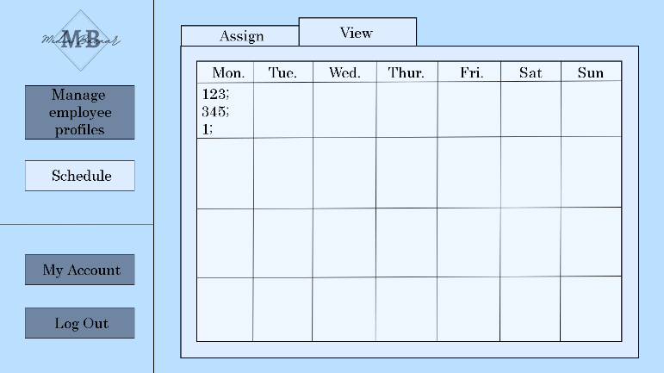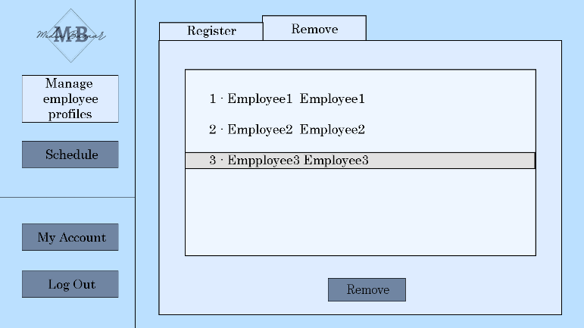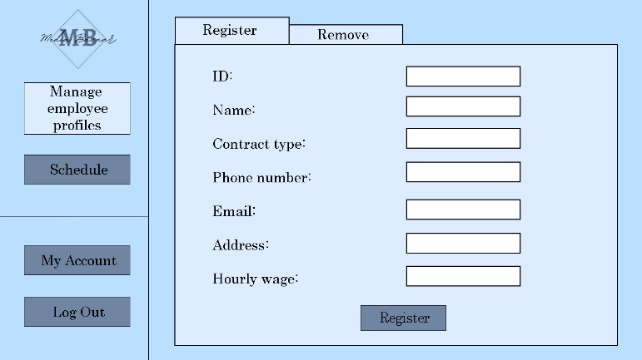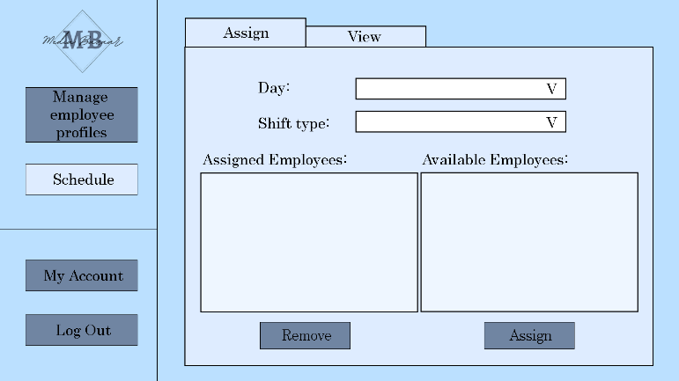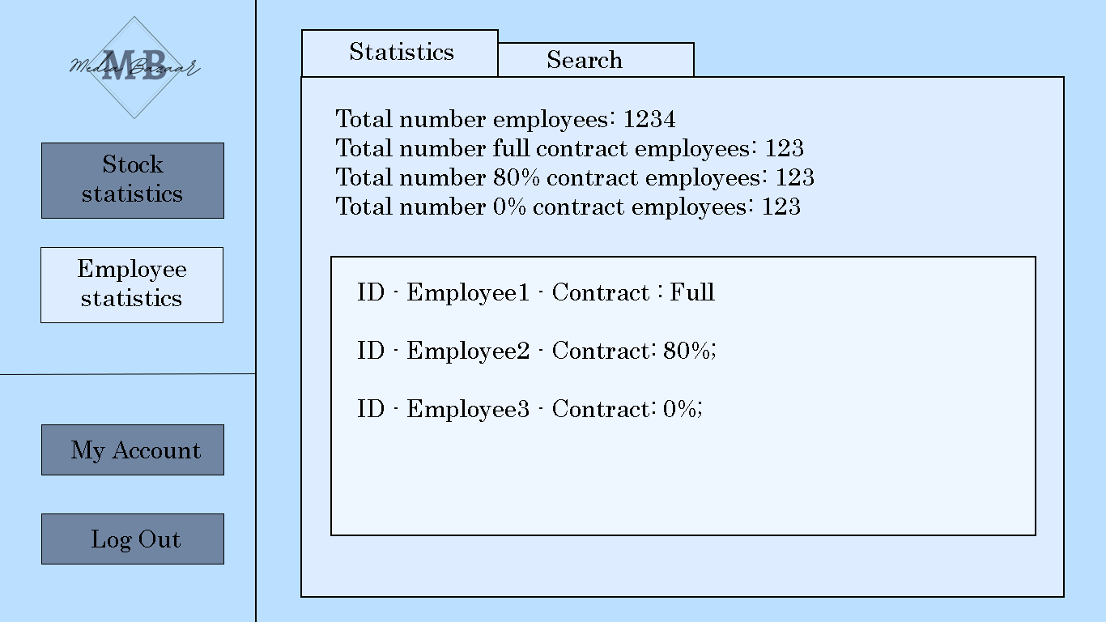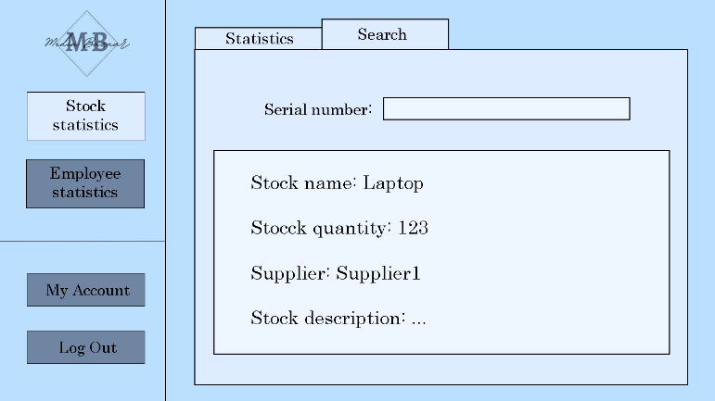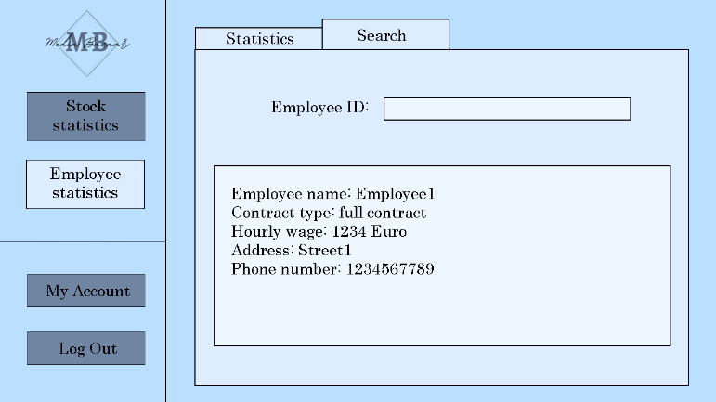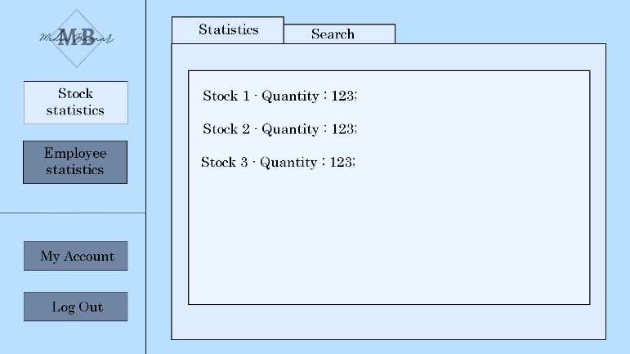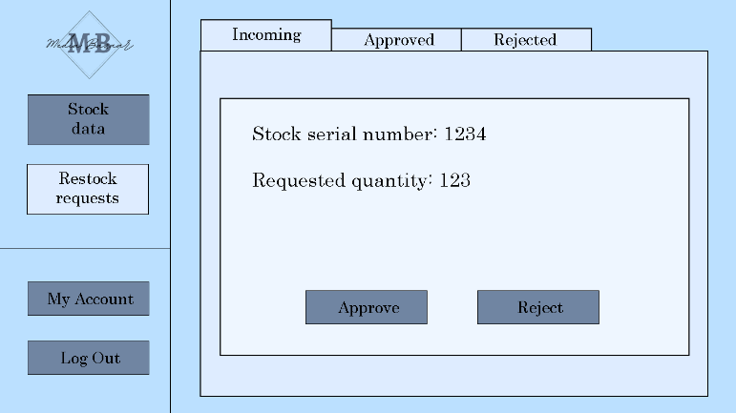

Here’s the shift for the week and the employee assigned to them.

Here is where can assign employee shifts.

This is how the HR admin removes employee.

This is how the HR admin adds employee.

Stock manager can search for an individual employee by their unique id number.

Department can see all the employees statistic.

Stuck manager can search for a specific product here.

Stuck manager can see stock statistic.

Stock worker can see the stock request.

# Website wireframe

Coming soon.